Hamilton Elementary
Meeting the individual needs of every student.

Dean Kramer, Principal Kim Sale, Secretary
dkramer@hamiltonschools.us ksale@hamiltonschools.us

Hamilton Elementary School
Annual Education Report (AER) Cover Letter

April 11, 2019

Dear Parents and Community Members:

We are pleased to present you with the Annual Education Report (AER) which provides key information on the 2017-18 educational progress for Hamilton Elementary School. The AER addresses the complex reporting information required by federal and state laws. The school’s report contains information about student assessment, accountability, and teacher quality. If you have any questions about the AER, please contact Dean Kramer for assistance.

The AER is available for you to review electronically by visiting the following web site – www.hamiltonschools.us, or you may review a copy in the main office at your child’s school.

For the 2017-18 school year, schools were identified using definitions and labels as required in the Every Student Succeeds Act (ESSA). A Targeted Support and Improvement (TSI) school is one that has at least one underperforming student subgroup. An Additional Targeted Support (ATS) school is one that has three or more underperforming student subgroups. A Comprehensive Support and Improvement (CSI) school is one whose performance is in the lowest 5% of all schools in the state or has a graduation rate at or below 67%. Some schools are not identified with any of these labels. In these cases, no label is given.

* Note TSI and ATS definitions were changed for the 2018-19 school year per federal requirements. The new definitions are:
- TSI – The school has at least one subgroup performing in the bottom 25% within each applicable accountability index component.
- ATS – The school has met the criteria for TSI identification and has at least one subgroup performing at the same level as a CSI school.
Our school has not been given one of these labels.

We are continuously working to improve. Our continued challenge is helping our bottom 30% of student to improve at the same rate as all students. We are also working to increase our overall achievement scores on the MSTEP in ELA and Math. Some of the major initiatives we are currently involved with are EBLI (Evidence Based Literacy Instruction), MIBLSI (Michigan’s Integrated Behavior and Learning Support Initiative), and Lucy Calkins Units of Study for Reading and Writing.

State law requires that we also report additional information.

Process for assigning students: Hamilton students are assigned to an elementary building by geographic area, but may be accepted to a different Hamilton elementary school through the in-district school of choice process. Students from outside the district may be accepted to a Hamilton Community Schools building as part of the schools of choice process, which considers the number of students already enrolled at each grade level to determine the number of openings available.

Status of the 3-5 year School Improvement Plan: The Hamilton Elementary school improvement process is coordinated with the district process; goals for improvement reflect the needs of the students in our building and support the Hamilton Community Schools’ District School Improvement Plan. The staff and parent representatives study student data, establish goals, and monitor progress. Goals include:
- (Academic) All students will be proficient in ELA and Math as measured by the MSTEP.
- (Social-Emotional) Perception data from Student Surveys will show an increase in respect as evidenced by an average rating increase of at least 0.25 on elements 3 & 4. Perception data from Parent Surveys will show an increase in scores regarding support services as evidenced by an average ratings increase of 0.5 points on the following elements: Parents – element 28.
- RIGOR – increase teacher knowledge ofrigor as evidenced by completion of rigor modules in Modern Teacher.

Core Curriculum: Hamilton Community Schools’ core curriculum is based on the Michigan Content Standards. These include the basic learning goals for students in the areas of math, reading, writing, science, social studies, physical education, art, and music. We also integrate the Skills 4 Success Framework: technology literacy, collaboration & global thinking, communication, critical thinking and problem solving, flexibility and adaptability, ethical citizenship, and personal accountability. All students have access to Hamilton’s core curriculum. Support is provided, as needed, through a variety of supportive services including special education, Title I (in Title I schools), MTSS, after school tutoring, summer school and individually planned accommodations. Information about the core curriculum is available in each school office and on the district website: www.hamiltonschools.us.

Aggregate Local Assessment Data:
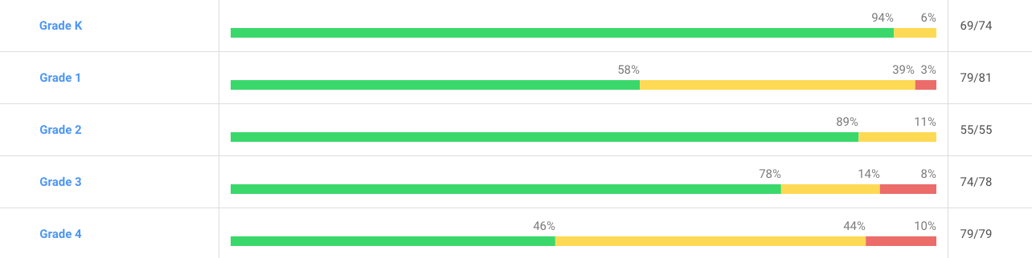
Parent-Teacher Conference Attendance: Attendance at parent-teacher conferences continues to be strong. Conferences are just one portion of the ongoing communication between home and school that strengthens the partnership. Hamilton Elementary continued the trend of very high participation in parent teacher conferences with parent participation at nearly 100% during the 2017-18 and the 2018-19 school year. In 2018-19 specifically, attendance was:
- 392/411 students represented, 95%
- 388/399 families represented, 97%

Closing Remarks: Hamilton Elementary students continue to demonstrate strong academic achievement, which is guided by our dedicated teachers, support staff, and parents. Thank you for your steadfast commitment to and continued support of our students!

Sincerely,
Dean Kramer, Principal
Hamilton Elementary School

3472 Lincoln Road, Hamilton, Michigan 49419
Phone: 269-751-5413
Fax: 269-751-7554

