

Blue Star Elementary

*Meeting the individual needs of every student.*

April 11, 2019

Dear Parents and Community Members:

We are pleased to present you with the Annual Education Report (AER), which provides key information on the 2017-18 educational progress for Blue Star Elementary. The AER addresses the complex reporting information required by federal and state laws. The school’s report contains information about student assessment, accountability, and teacher quality. If you have any questions about the AER, please contact Nicholas Damico for assistance.

The AER is available for you to review electronically by visiting the following web site [Hamilton Community Schools](http://www.hamiltoncommunityschools.us). Select schools and click on Blue Star Elementary.

For the 2017-18 school year, schools were identified using definitions and labels as required in the Every Student Succeeds Act (ESSA). A Targeted Support and Improvement (TSI) school is one that has at least one underperforming student subgroup. An Additional Targeted Support (ATS) school is one that has three or more underperforming student subgroups. A Comprehensive Support and Improvement (CSI) school is one whose performance is in the lowest 5% of all schools in the state or has a graduation rate at or below 67%. Some schools are not identified with any of these labels. In these cases, no label is given.

\* Note TSI and ATS definitions were changed for the 2018-19 school year per federal requirements. The new definitions are:

TSI – The school has at least one subgroup performing in the bottom 25% within each applicable accountability index component.

ATS – The school has met the criteria for TSI identification and has at least one subgroup performing at the same level as a CSI school.

Our school was identified as not having one of these labels.

We are continuously working to improve. Our continued challenge is helping our bottom 30% of students to improve at the same rate as all students. We are also working to increase our overall achievement scores on the M-STEP in ELA and Math. Some of the major initiatives we are currently involved with are EBLI (Evidence Based Literacy Instruction), Lucy Calkins Units of Study, and MIBLSI (Michigan Integrated Behavior and Learning Initative).

State law requires that we also report additional information.

**PROCESS FOR ASSIGNING PUPILS TO THE SCHOOL** Hamilton students are assigned to an elementary building by geographic area, but may be accepted to a different Hamilton elementary school through the in-district school of choice process. Students from outside the district may be accepted to a Hamilton Community Schools building as part of the schools of choice process, which considers the number of students already enrolled at each grade level to determine the number of openings available.

**THE STATUS OF THE 3-5 YEAR SCHOOL IMPROVEMENT PLAN** The Blue Star Elementary school improvement process is coordinated with the district office; goals for improvement reflect the needs of the students in our building and support the Hamilton Community Schools’ District goals, and monitor progress. Goals for improvement in 2017-2018 include:

* All students will be proficient in ELA and Math as measured by the M-STEP.
* Perception data from staff and parent surveys will show an increase in Average Score of 0.5 in question “Our school provides excellent support services.”
* Increase teacher knowledge of rigor as evidenced by the completion of rigor modules in Modern Teacher.

**CORE CURRICULUM** Hamilton Community Schools’ core curriculum is based on the Michigan Content Standards. These include the basic learning goals for students in the areas of math, reading, writing, science, social studies, physical education, art, and music.  We also integrate the Skills 4 Success Framework: technology literacy, collaboration & global thinking, communication, critical thinking and problem solving, flexibility and adaptability, ethical citizenship, and personal accountability.  All students have access to Hamilton’s core curriculum. Support is provided, as needed, through a variety of supportive services including special education, Title I (in Title I schools), MTSS, after school tutoring, summer school and individually planned accommodations.  Information about the core curriculum is available in each school office and on the district website: [www.hamiltonschools.us](http://www.hamiltonschools.us/" \t "_blank).

**Aggregate Local Assessment Results**

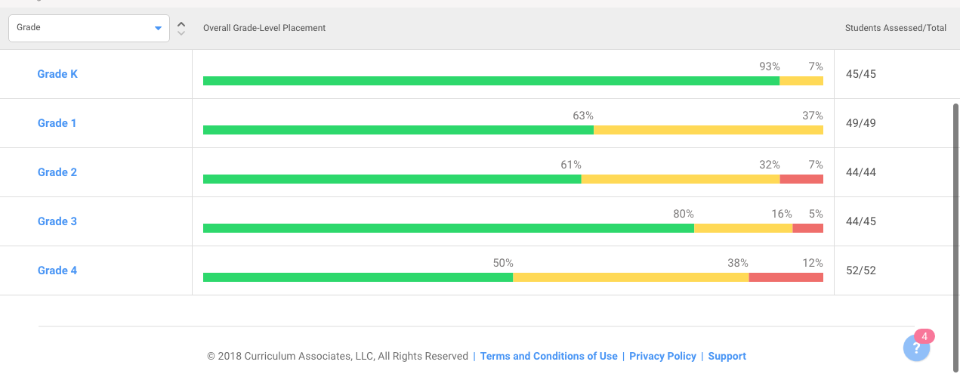

**Parent Conference Data** Attendance at parent-teacher conferences continues to be high. This is just one portion of the ongoing communication between home and school that strengthens the partnership. Blue Star Elementary continues to have high parent participation rates.

Fall 2018: 97%

Spring 2019: 97%

At Hamilton Community Schools we our mottos is that *Each Will Thrive*. This is our commitment to each every student that walks through our doors. Blue Star Elementary continues to perform in comparison to the state of Michigan, but we follow a model of continuous improvement in all that we do. Blue Star has a dedicated teaching staff, supportive parents, and the amazing students!

Sincerely,

Nicholas Damico-Principal

Blue Star Elementary School