Dear Hamilton Community,
If your family enjoys skiing/snowboarding or have always wanted to try the sport here is an opportunity with discounted rates. Bittersweet allows those in an organized group to buy a savings card that allows for fabulous savings for ski/snowboard equipment rentals and lift tickets. Cards are $22.00 for students or adults and the discount is significant.

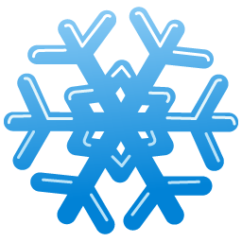
Lift Tickets
 | Ski Club Price | Regular Price | Discount
Monday - Friday (open to close)
Student | $22.00 | $45.00 | ($23.00)
Adult | $26.00 | $45.00 | ($19.00)
Saturday - Sunday (available after 3:00)
Student | $22.00 | $57.00 | ($35.00)
Adult | $26.00 | $57.00 | ($31.00)
equipment rental also has a discount of $9.00-$13.00 (33% - 37%!)

Skiing weather will be here before we know it and Bittersweet, which is only twenty-five minutes away in Otsego, promises that their snowmaking capabilities assure that they have snow in their backyard even when you don’t have it in yours!

Please note that this is not a “school sponsored” activity, but rather an opportunity that I chose to coordinate to allow families who enjoy skiing to get a great discount at Bittersweet. All you have to do is fill out a form for each child, adult form for each adult, enclose a check payable to Bittersweet Ski Resort ($22.00 per card) and mail your information to me at:
Marcy Beyer
4441 Whisper Ct.
Hamilton, MI 49419
Once I receive your information I will mail back your ski club cards.
This opportunity can be shared with family and friends who would like to ski at a discount as well.

Please feel free to contact me with any questions you may have at 616-212-9281.
You can check out the Bittersweet Ski Resort website at www.skibittersweet.com

Hope to see you on the slopes,
Marcy Beyer
Hamilton Community Ski/Snowboard Coordinator

