Yoga Stretching for Better Sleep
- Upside-Down Relaxation: Sit facing a wall with your bottom about 6 inches away from it. Lie back and extend your legs up the wall. If this is too intense of a stretch, slide your bottom farther away from the wall. If it’s not intense enough, move closer. Let your arms rest by your sides, palms facing up, and breathe gently, feeling the stretch in the backs of your legs. Hold for two minutes.
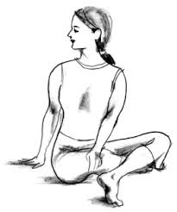
- Winding Down Twist: Sit cross-legged on the bed and exhale as you place your right hand on your left knee and left hand on the bed behind your tailbone. Gently twist your torso to the left. Allow your gaze to follow, looking over your left shoulder. Breathe deeply, then return to center and repeat on opposite side. Hold for one minute on each side.

- Sleepy Time Stretch: Lie on your back with knees bent. Place the soles of your feet together, then let your knees fall open, forming a diamond shape with your legs. Rest your arms on the bed. Hold for two minutes.

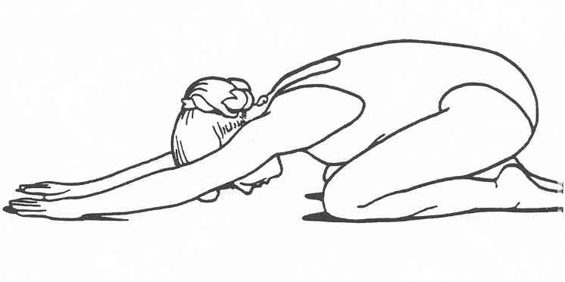
- Child’s Pose: Sit up comfortably on your heels. Roll your torso forward, bringing your forehead to rest on the bed in front of you. Lower your chest as close to your knees as you comfortably can, extending your arms in front of you. Hold the pose and breathe for two minutes.

- Rock-a-bye Roll: Lying on your back, hug knees in to chest. Cross your ankles and wrap both arms around your shins with clasped hands. Inhale and rock your body up to sit; exhale as you roll back. Continue for one minute.

