
Hamilton Middle School
Prices

Breakfast Free
Lunch Free
September/October
25  *Chicken Leg w/Mashed Potatoes & Dinner Roll  *Philly Cheesesteak Sandwich  Cooked Garden Corn | 26  *Pulled Pork Sandwich  *Sausage Egg & Cheese Bagel Sandwich  Baked Beans | 27  *Chicken Bacon Sandwich  *Cheese Stuffed Breadsticks w/Dipping Sauce  Cooked Green Beans | 28  *Deluxe Nachos  *Hot Dogs  *Strawberry Parfait w/Cereal Bar  *Pizza Pocket  Fresh Broccoli | 29  *Ham & Cheese Calzone  *Corn Dog  *Chicken Nuggets w/Crackers  Cooked Garden Corn  Can you believe?  Only 92 more days in 2023
02  *Beef/Bean & Cheese Burrito  *Chicken Tenders w/Cheese Crackers  *Pepperoni Pizza Pocket  Cooked Garden Corn | 03  *Soft Shell Tacos  *Breaded Chicken Sandwich  Baked Beans | 04  *Apple Cinnamon French Toast w/Sausage Patties  *Cheese Stuffed Breadsticks w/Dipping Sauce  Cooked Green Beans | 05  *Beef Taco Sticks  *Orange Chicken Stir Fry w/Rice & Fortune Cookie  *Mini Corn Dogs  Fresh Broccoli | 06  *Chicken Cheese Quesadilla  *Mozz. Cheese Sticks w/Dipping Sauce  *Ham & Cheese Calzone  Cooked Garden Corn
09  *Chicken Leg w/Mashed Potatoes & Dinner Roll  *Italian Pull Apart Cheese & Garlic Bread w/Dipping Sauce  Cooked Garden Corn | 10  *Pulled Pork Sandwich  *Sausage Egg & Cheese Bagel Sandwich  Baked Beans  Did you know???  The state of Illinois grows the most pumpkins in the US. | 11  *Chicken Bacon Sandwich  *Cheese Stuffed Breadsticks w/Dipping Sauce  Cooked Green Beans | 12  *Deluxe Nachos  *Hot Dogs  *Strawberry Parfait w/Cereal Bar  *Pizza Pocket  Fresh Broccoli | 13  Half Day  
16  *Beef/Bean & Cheese Burrito  *Chicken Tenders w/Cheese Crackers  *Pepperoni Pizza Pocket  Cooked Garden Corn | 17  *Soft Shell Tacos  *Breaded Chicken Sandwich  Baked Beans | 18  *Apple Cinnamon French Toast w/Sausage Patties  *Cheese Stuffed Breadsticks w/Dipping Sauce  Cooked Green Beans | 19  *Beef Taco Sticks  *Popcorn Chicken Bowl  *Mini Corn Dogs  Fresh Broccoli | 20  *Chicken Cheese Quesadilla  *Mozz. Cheese Sticks w/Dipping Sauce  *Ham & Cheese Calzone  Cooked Garden Corn
23  *Chicken Leg w/Mashed Potatoes & Dinner Roll  *Philly Cheesesteak Sandwich  Cooked Garden Corn | 24  *Pulled Pork Sandwich  *Sausage Egg & Cheese Bagel Sandwich  Baked Beans | 25  *Chicken Bacon Sandwich  *Cheese Stuffed Breadsticks w/Dipping Sauce  Cooked Green Beans | 26  No School | 27  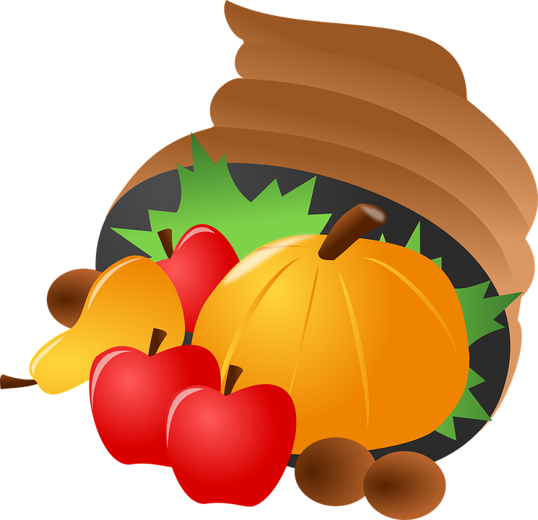No School

MONDAY TUESDAY WEDNESDAY THURSDAY FRIDAY

Monday Tuesday Wednesday Thursday Friday
Mini Pancakes | Choc. Chunk Benefit Bar | Whole Grain Mini Cinnamon Rolls | Whole Grain Apple or Cherry Frudels | Warm Maple Waffles

Daily Breakfast Entrées Include: 100% Asst. Fruit Juices, Fresh and Asst.Canned Fruit.
1% White and Skim Chocolate Milk (Cereal Kits also available daily)

Available Daily
*Hamburgers/*Cheeseburgers/*Chef Salads
*Turkey & Cheese Sub Sandwiches/*Cheese & Pepperoni Pizza Hut Pizza

Due to product availability Menus are subject to change

*Included daily with lunch are several choices of fruit and vegetables.
Fruit Choices.
Apples, Oranges, Watermelon, and Grapes (seasonal), canned in juice, Peaches, Applesauce, Pears, Pineapple and Mandarin Oranges.
100% Apple, Orange and Grape Juice.
Vegetable Choices.
In addition to the daily hot choice, Fresh Baby Carrots, Celery and Broccoli.
Also 1% White and Chocolate Milk.
*All breads and breading are whole grain.

USDA is an equal opportunity provider and employer.
Breakfast
Breakfast Meal Deal
(1) Entrée Choice
(2) Fruit or Fruit Juice
(1) Low-Fat 1% or Skim Milk (8oz)

Lunch Meal Deal
(1) Entrée Choice (bread & protein)
(2) Fruit Choices
(2) Vegetable Choices
(1) Low-Fat 1% or Skim Milk (8oz)

