
Hamilton Middle School
Prices

Breakfast $1.65
Lunch $2.95
September-October Menu
26  *Chicken Leg w/Waffle  *Ham/Pepperoni/Salami & Cheese Stromboli  Cooked Garden Corn | 27  *Pulled Pork BBQ Sand.  *Sausage Egg & Cheese Bagel Sandwich  Baked Beans | 28  *Chicken Bacon Sandwich  *Cheese Stuffed *Breadsticks w/Dipping Sauce  Cooked Green Beans | 29  *Deluxe Nachos  *Hot Dogs  *Strawberry Parfait w/Cereal Bar  *Pizza Pocket  Fresh Broccoli | 30  *Ham & Cheese Calzone  * Corn Dog  *Chicken Nuggets w/Crackers  Cooked Garden Corn
03  *Chicken Tenders w/Cheese Crackers  *Pepperoni Pizza Pocket  Cooked Garden Corn | 04  *Soft Shell Tacos  *Breaded Chicken Sandwich  Baked Beans | 05  *Pancakes w/Sausage Patties  *Cheese Stuffed *Breadsticks w/Dipping Sauce  Cooked Green Beans | 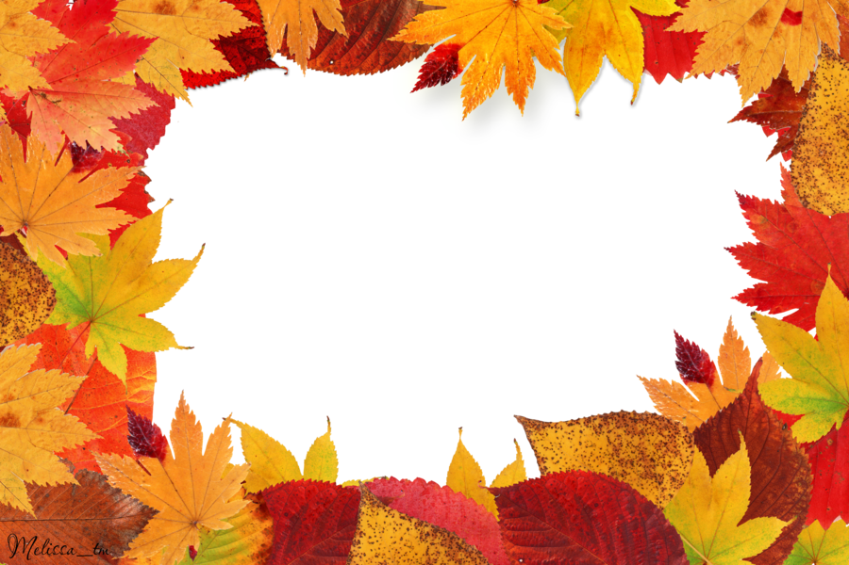 06  *Pork Rib Sandwich  *Popcorn Chicken Bowl w/Mashed Potatoes  *Mini Corn Dogs  Fresh Broccoli | 07  Half Day
10  *Chicken Leg w/Mashed Potatoes & Dinner Roll  *Philly Cheesesteak Sub  Cooked Garden Corn | 11  *Pulled Pork BBQ Sand.  *Sausage Egg & Cheese Bagel Sandwich  Baked Beans | 12  *Chicken Bacon Sandwich  *Cheese Stuffed *Breadsticks w/Dipping Sauce  Cooked Green Beans | 13  *Deluxe Nachos  *Hot Dogs  *Strawberry Parfait w/Cereal Bar  *Pizza Pocket  Fresh Broccoli | 14  *Pizza Bite Crunchers  * Corn Dog  *Chicken Nuggets w/Crackers  Cooked Garden Corn
17  Chicken Tenders w/Cheese Crackers  *Pepperoni Pizza Pocket  Cooked Garden Corn | 18  *Soft Shell Tacos  *Breaded Chicken Sandwich  Baked Beans | 19  *French Toast Sticks w/Sausage Patties  *Cheese Stuffed *Breadsticks w/Dipping Sauce  Cooked Green Beans | 20  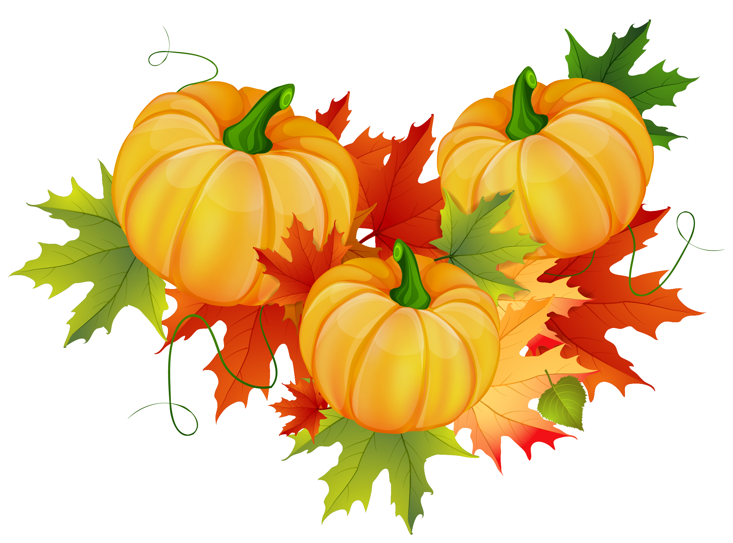No School | 21  No  School
24  *Chicken Leg w/Waffle  *Ham/Pepperoni/Salami & Cheese Stromboli  Cooked Garden Corn | 25  *Pulled Pork BBQ Sand.  *Sausage Egg & Cheese Bagel Sandwich  Baked Beans | 26  *Chicken Bacon Sandwich  *Cheese Stuffed *Breadsticks w/Dipping Sauce  Cooked Green Beans | 27  *Deluxe Nachos  *Hot Dogs  *Strawberry Parfait w/Cereal Bar  *Pizza Pocket  Fresh Broccoli | 28  *Ham & Cheese Calzone  * Corn Dog  *Chicken Nuggets w/Crackers  Cooked Garden Corn

MONDAY TUESDAY WEDNESDAY THURSDAY FRIDAY

Monday Tuesday Wednesday Thursday Friday
Mini Pancakes w/String Cheese | Choc. Chunk Benefit Bar | Whole Grain Mini Cinnamon Rolls | Whole Grain Apple or Cherry Frudels | Warm Maple Waffles

Daily Breakfast Entrées Include: 100% Asst. Fruit Juices, Fresh and Asst.Canned Fruit.
1% White and Skim Chocolate Milk (Cereal Kits also available daily)


Available Daily
*Hamburgers/*Cheeseburgers/*Chef Salads
*Turkey & Cheese Sub Sandwiches/*Cheese & Pepperoni Pizza

Due to product availability Menus are subject to change

*Included daily with lunch are several choices of fruit and vegetables.
Fruit Choices.
Apples, Oranges, Watermelon, and Grapes (seasonal), canned in juice, Peaches, Applesauce, Pears, Pineapple and Mandarin Oranges.
100% Apple, Orange and Grape Juice.
Vegetable Choices.
In addition to the daily hot choice, Fresh Baby Carrots, Celery and Broccoli.
Also 1% White and Chocolate Milk.
*All breads and breading are whole grain.

USDA is an equal opportunity provider and employer.
Breakfast
Breakfast Meal Deal
(1) Entrée Choice
(2) Fruit or Fruit Juice
(1) Low-Fat 1% Milk (8oz)

Lunch Meal Deal
(1) Entrée Choice (bread & protein)
(2) Fruit Choice
(2) Vegetable Choice
(1) Low-Fat 1% Milk (8oz)

